THE ROYAL CLARENCE OF BRUTON

On Nov. 2nd, 1940, a warrant was obtained by the Bruton Masons under our old name, Royal Clarence, and the Lodge there was constituted 6th April, 1841. They obtained some of our furniture and a book containing our Bye laws, which original book was kindly lent to the writer, together with the plate for printing our certificates, which we issued in early days to each initiate.
Plate 1. shows the outside cover of the book. Printed inside is a label shaped like a double square, surrounded- by gold ornament, not of a Masonic character, and a similar ornament in gold surrounds the whole cover.
The book is about 15 inches by 10 inches, and the back is similarly ornamented.
On the second page is a beautiful example of old pen-manship, with many ornamentations and a glory of flourishes, and in writing is a copy of the printing outside.
But the word “Frome” is struck through in pencil, and the word “Bruton,” in pencil, substituted. (See Plate11.).
Page 3 is an elaboration of the two foregoing pages, and has had more alterations than the others (see plate III.)
The No. 695 is evidently an alteration. The Frome number was 560. The figure 5 has been erased, the number 6 allowed to remain, a tail-put to the original 0 and the figure 5 added – making695. In the book the 5 becomes too close to the flourish to have been so placed originally ; there is too much space between the “No.” and the next figure ---the 6.
The A L 5840 and A D 1840 have been somewhat simarlv treated, in order-to the date for the Bruton Royal Clarence.

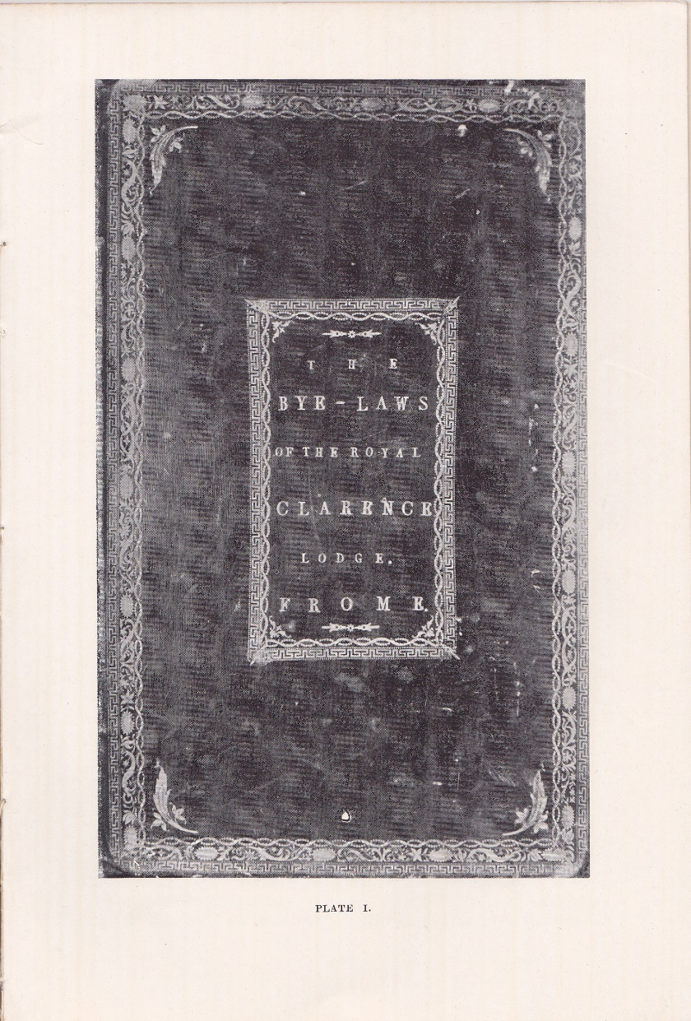

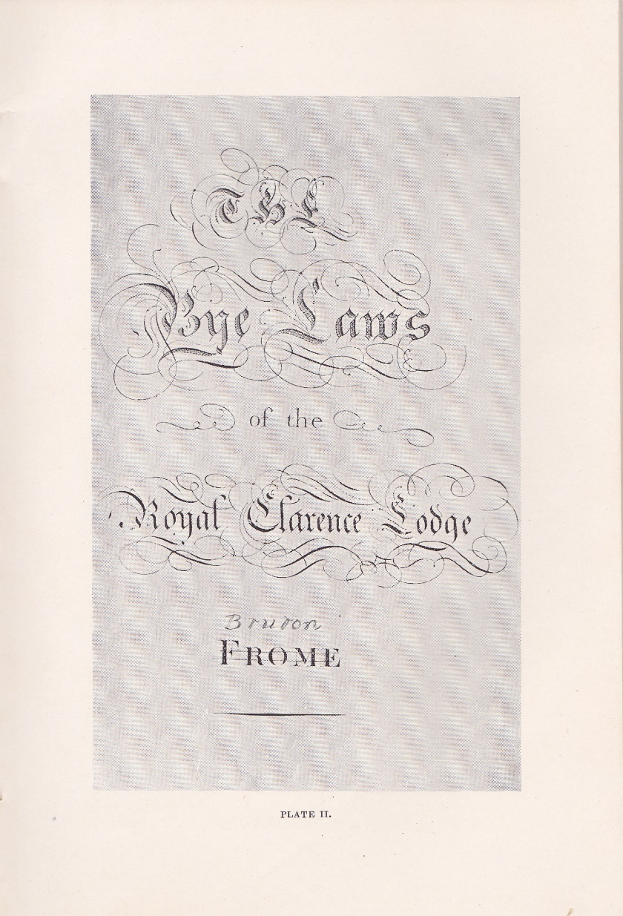
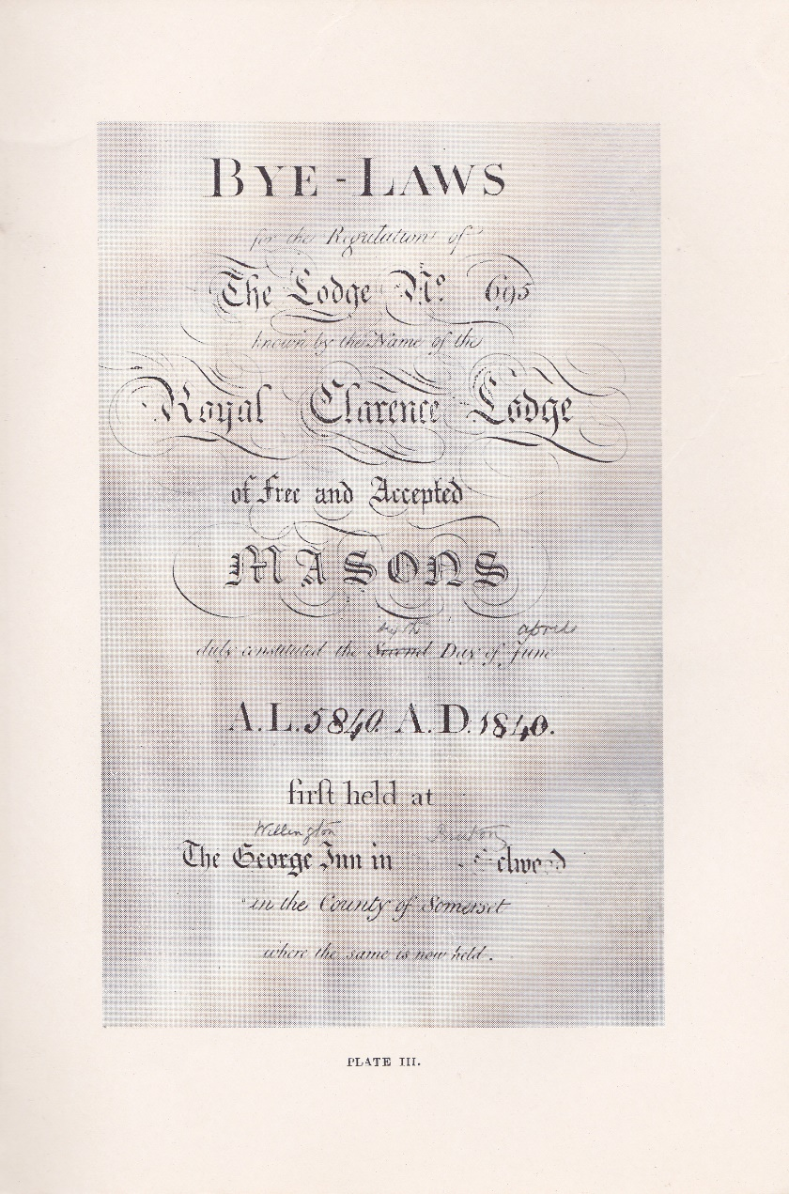

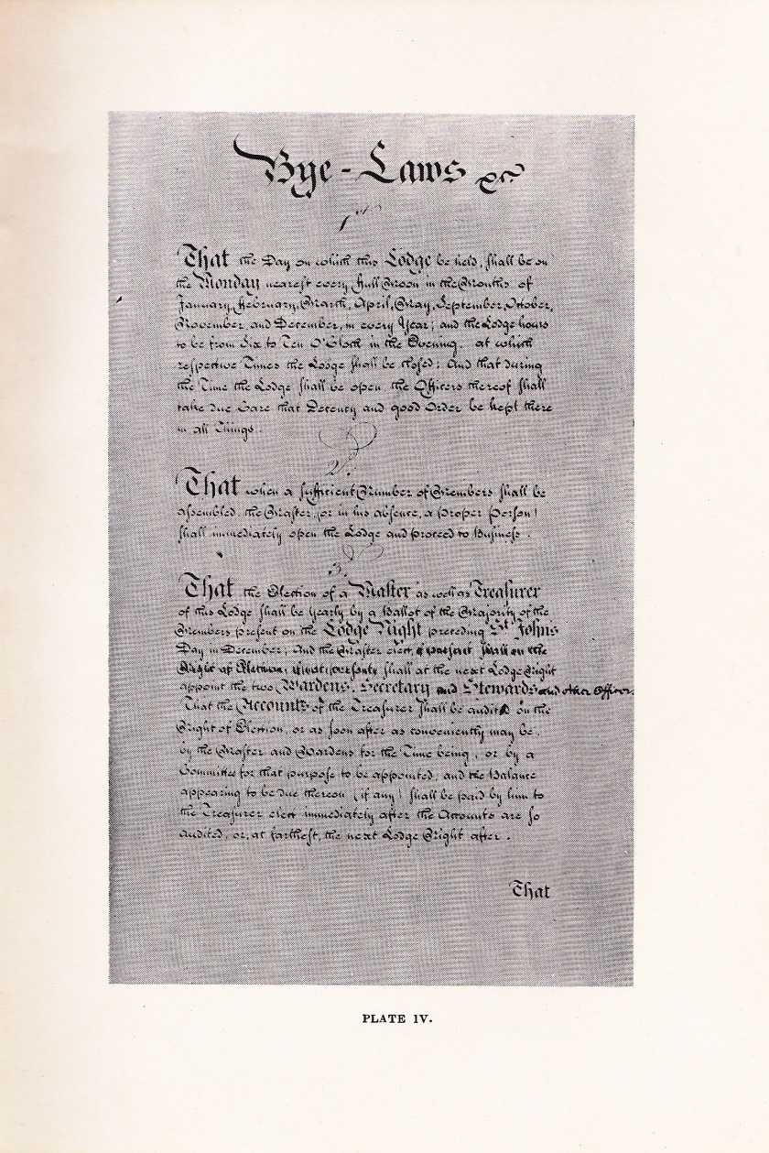

The line " The George Inn in Selwood” was evidently abandoned, and a pencil used to strike out the word " George " and, write over it “ Wellington ”; Frome remains faintly and Bruton is written over it in pencil.
The Bruton Lodge first met at the Wellington Inn. The Frome Royal Clarence always met at the George, Frome- Selwood.
The illustration of the first three Bye-Laws shows the beautiful handwriting of the time. (see Plate IV.)
I think the Bye-laws are sufficiently interesting to be given in full. as, of course, they were the original Bye-laws of our old Lodge. Much internal evidence is obtainable from them, which points to a stern discipline, and. Throws light on the habits and customs of that time.

BYE-LAWS.
1ST
That the day on which this Lodge be held shall be on the Monday nearest every full moon in the months of January, February, March, April, May, September, October, November and December in every year ; and the Lodge hours to be from six to ten o'clock in the evening. At which respective times the Lodge shall be closed. And that, during the time the Lodge shall be open the Officers thereof shall take due care that Decency and good ord.er shall be kept in all things.
2ND.
That when a sufficient number of Members shall be assembled the Master (or in his absence, a proper person) shall immediately open the Lodge and proceed to business.

3RD.
That the election of a Master as well as a Treasurer of this Lodge shall be yearly by a ballot of the majority of the Members present, on the Lodge night, preceding St. John's Day in December, and the Master-elect, if present, shall of the night of election, if not present, shall on the next Lodge night, appoint the two wardens, secretary and stewards, and. other officers.
That the accounts of the Treasurer shall be audited on the night of election, or as soon after as convenient may be, by the Master and Wardens, for the time being, or by a committee for that purpose to be appointed ; and" that the balance appearing to be due thereon (if any), shall be paid by him to the 'Treasurer-elect immediately after the accounts are so audited, or at farthest the next Lodge night after.
4TH.
That the Tyler of this Lodge shall be appointed by the Master, with the consent of the members present, on every election night or as often as there shall be occasion, and shall be continued only during his good behaviour: whose duty it is to attend the Secretary, to receive the summonses and deliver them to the members in due time ; to attend every Lodge night; to set out the furniture of the Lodge, to guard the door and to do such other necessary business as may be required of him. For which he shall be paid as follows :-- That is to say : for every night's attendance one shilling. And for the making or raising any brother eighteen pence for each degree. But in case he shall neglect or refuse to attend in due time, whereby the business of the Lodge may be retarded, he shall forfeit and pay to the Lodge for every such neglect or refusal Five Shillings, unless he shall be prevented by sickness or any material business, in which case he shall provide a proper substitute at his own expense.
5TH.
That every Member of the Lodge shall pay to the Treasurer for the time being for the use of the Irod.ge, the yearly sum of one pound one shilling, by equal quarterly payments : that is to say : on the first Lodge night after the 25th day of March, the 24th day of June, the 29th day of September, and the 25th day of December, which will entitle such member to his liquor not exceeding two shillings and sixpence per bottle. And if any member shall neglect or refuse to pay his quarterage within three months after every quarter-day, having had his notice thereof from the Secretary, he shall be expelled as a member of, and be excluded from visiting this Lodge : unless good cause shall be shown to the satisfaction of the Master and Brethren to induce them to a forbearance.
6TH.
That as nothing has a greater tendency to bring the Craft into disrepute than keeping late hours on Lodge nights, the Master shall be acquainted by the Senior Warden when it is ten o'clock, and shall immediately proceed to close the Lodge, either of them failing herein shall forfeit the sum of five shillings. And every member who is in the Lodge (not being a traveller, or lodger in the house) remaining in the same house after twelve o'clock shall also forfeit the sum of five shillings.
It is hoped and expected that no member will offend against this law, calculated to secure the honor and harmony of the Lodge, to prevent uneasiness at home, and to preserve the economy of our families.
7TH.
That the election of any person to be made a Mason in this Lod.ge shall be by ballot ; and in case any ball shall be found in the negative drawer, he shall be immediately balloted for again, to avoid mistakes; but in case, on a second ballotting, one or more balls shall be still be found in the negative side, the election of the person so proposed shall be postponed for the space of three months only, at which time he shall be ballotted for again.
The member proposing any candidate shall, upon his election, immediately pay into the hands of the' Treasurer the sum of one pound one shilling, which shall be considered as part of the fee for making such candidate, if he appears in proper time to be made.
8TH.
That the expense of making to every person shall be the sum of four guineas, to be paid into the hands of the Treasurer of this lodge (a pencil note here, 4th May, 1822, raised to five guineas.-J.O.L.) which sum shall entitle him to the three degrees without further expense, including certificate, registering, one quarter's expenses, and the Tyler’s fees) unless such person so made a Mason shall afterwards prove an unworthy member of the Craft by treating disrespectfully, either by words or actions or leading an immoral and scandalous life : in which case such person shall not be entitled to any further degree in this Lodge.
9TH.
That in case any person who shall be proposed to be made a Mason in this Lodge, and shall be duly elected for that purpose, shall not, within the space of six regular Lodge nights from the time of such election, make or cause to be made, application to this Lodge to be made a Mason, such election shall be null and void", and the money deposited shall be forfeited., unless he can assign any satisfactory reason to this Lod.ge for such his delay.
And whereas propositions have been made, and consent by ballot obtained in favour of persons outwardly and apparently good and well-meaning men who were afterwards found to be vile and unworthy the Society of Masons : Be it remembered that notwithstanding a candidate may be proposed and his election obtained by ballot, if such person shall afterwards be found to be a man unworthy to be admitted into this ancient and honourable fraternity, such balloting shall be void in as full and ample a manner to all intents and purposes as if such propositions had never been made, and such consent by ballot had never been given. And in that case the money deposited shall be returned.
10TH.
That if any entered apprentice or fellow craft Mason, not having been made in this Lodge, shall be desirous of being passed or raised to the degree of a fellow craft or Master Mason in this Lodge (as the case may be) he shall be proposed by some member of the Lodge for that purpose, and be balloted for in a full Lodge. And. upon his having every ball in his favour he shall, after such balloting be passed or raised to the degree of a fellow craft or Master Mason (as the case may be) on payment to the Treasurer of this Lodge of the sum of one guinea and a half for each degree. But in case such candidate so elected as aforesaid shall be desirous of being passed or raised to the degree of a fellow craft or Master Mason (as the case may be) at any other time than the usual stated Lodge night, and an extra Lodge be summoned at his request for that purpose, such candidate shall then pay the whole expense of such extra Lodge over and above the respective sums before-mentioned for such passing and raising.
11TH
That every brother who shall be desirous of being accepted a member of this Lodge, not having been made in this Lodge, shall, on his admittance, pay to the Treasurer thereof for the time being the sum of two guineas (struck out, and one guinea put in-J.O.L.) such admission to be determined by ballot.
12TH.
That all brothers becoming members of this Lodge shall be deemed as such, and be accountable for their Quarterage so long as their names shall continue on the book. Should any brother, therefore, be desirous of withdrawing himself as a member, upon giving one month's notice thereof in writing, or signifying the same in person on any stated Lodge night, and paying his arrears, if any be due from him to the Lodge, he shall immediately have his name struck off the list of members and a minute shall be made of the same.
13TH.
That every brother who shall visit this Lodge shall pay into the hands of the Treasurer thereof for the time being the sum of four shillings, which shall entitle him, such visitor, to his supper and to liquor not exceeding two shillings and six-pence per bottle. But be it understood, nevertheless, that the visiting fee of this Lodge is four guineas, and shall be paid by such visitor if demanded.
14TH.
That no smoking of tobacco shall be allowed in the Lodge, or in the supper-room during Lodge hours ; and if any brother shall attempt to introduce it, he shall forfeit five shillings.
15TH.
That no brother shall swear or use any abusive language, or come into the Lodge intoxicated with liquor, nor shall on any account call for wine or other liquors, but address himself to the Stewards, who, if they think it necessary, will, with the consent of the Master, give their orders accordingly. That all brethren behave themselves with decency to each other, and with respect to the Master in the chair, and presiding officers. That no member shall be permitted to leave the lodge room without consent of the Master, and in case of default in either of these particulars the brother so offending shall forfeit and pay the sum of five shillings.
16TH.
That any member behaving in such a manner when out of the Lodge as to be the occasion of scandalous and unworthy reflections being cast on this Society, or being so troublesome in the Lodge as to destroy the peace and harmony thereof, such brother sha1l be thrice duly admonished by the Master and Wardens in a Lodge formed, and if he does not restrain his imprudence, nor obediently submit to the advice of his brethren, he shall be discontinued a member of the Lodge, and never afterwards admitted as a visitor.
17TH.
That the Treasurer of the Lodge for the time being shall, pay the house expenses of each Lodge night at the end of every quarter, and the sum of one shilling to the waiter attending the Lodge each Lodge night, and shall also pay for each person's supper visiting this Lodge.
18TH.
That all fines and forfeitures inflicted by this Lodge shall be immediately paid to the Treasurer on pain of expulsion, and shall be applied to the use of this Lodge.
19TH.
That when a motion is made for any new Law, or for abolishing or altering any old one, it shall be first handed up in writing to the Master, in order to be read and considered by him and the members present, and no new Law nor abrogation or alteration of any old one shall be valid unless the same be entered in the minutes by consent of at least two-thirds of the whole members of the Lodge at one public lodge, and duly confirmed at the next.
20TH.
That the Master shall order the bye-laws to be read by the Secretary or some other brother the first Lodge night in every quarter.
21ST.
That the foregoing Bye-laws shall be signed by every member of this Lodge, signifying their assent and consent thereto, and their determination to abide by and confirm to the same.

On the top of the next page appears the following:-
We, the Master, Wardens and other officers and members of this Lodge, having attentively perused or heard read the foregoing Bye-laws, do hereby approve of the same, and give our full assent and consent thereto, and are determined to abide by and conform to them. And as a testimony thereof have hereunto subscribed our names the (fifteenth) day of February in the year of Masonry (5842)
and in the year of our Lord" (1842)

The word fifteenth, and the dates 5842 and 1842, are interpolated. There have been several pages cut out from the original book up to the above line, and leaving a margin on the left side of the original writing as a heading, but the word and dates have been placed there after the original ones erased.
Then follows the list of names of members of the Bruton Lodge, instead of those of the Frome Royal Clarence, which evidently were there originally.
The Bruton Lodge has the book of the original minutes of their old Lodge, and they are to be congratulated.

NOTES ON SOMERSET EARLY PROV.
GRAND MASTERS

The first Prov. Grand Master for Somerset was John Smith, of Combe Hay, near Bath. He was son of Robert Smith, who was born in Frome in 1701. This Robert Smith had a brother John, born in 1704. Their father, Robert Smith, died in 1705, leaving these two infant boys to be brought up by their grandfather, a Robert Smith again. This grandfather, a clothier of Frome had gone to Stoney Littleton to live, on the marriage of his son Robert in 1699 with Margaret Kingman. He also owned Foxcote, where he was buried in 1714, and Combehay.
Our P.G. Master's uncle, John Smith, dying in 1768, S.P. left his nephew John his sole heir. As he inherited his father's large estate, too, in 1755, he must have been a wealthy man. He married the Hon. Ann Tracy, third daughter of Charles Viscount Tracy.
He was M.P. for Bath, 1766, 1768 and.1774. When he became P.G.M. for Somerset is uncertain. The Year Book of Grand Lodge gives 1770 as the date, but in the Somerset Masters' Transactions for 1921, page 320, giving the minutes of the Bear Lodge, is the following:-June 28, 1768. This day Sir Robert Burdett, Bart., and Samuel Eyres, Esq., were, by dispensation of the Prov. G.M. for Somersetshire duly made Masons at Combe Hay, in the house of John Smith, Esq., P.G.M. and paid for their making three guineas each.
Then the Lodge was adjourned to the White Hart, Bath, and held there this evening by the officers and brothers thereof. This night Bros. Sir Robert Burdett, Esq., and Samuel Eyres, Esq. (and four others) were made fellow-craft at the White Hart Lodge by Brother Dunckerley, P.G.M. for Hampshire.
This seems quite conclusive that John Smith was P.G. Master for Somerset in Juno, 1768.
He died in November, 1775.
The Masonic Year Book gives no successor until 1784, when Bro. Thomas Dunckerley was appointed. He held the post until 1795, when he died.
Next year Bro. Col. John Smith, who was the son of John Smith, our first P.G.M', undertook the honour and held it until his death on August 1st, 1813, aged 54.
He was initiated Jan. 15th, 1788, and received the Fellow Craft the same night. He was raised on Feb. 5th, and made a member of the Lodge at the same meeting (Somt. Masters' Trans., 1923, P. 64)'

He changed his name by Deed Poll in 1803 or 1804, taking that of Leigh, but his object in doing so seems to have been unsuccessful. He sold a good deal of his property just about that time. In 1786 he sold Stonev Littleton to Sir John Hugh Smith, of Ashton Court.
Much of his Frome property, too, changed hands in the last ten years of that century, the loss of an expensive law suit being one of the reasons.
This Bro. John Smith was Master of the Lodge meeting at the Bear Inn, Bath, for several half-years, as was the custom of the time, viz., 1791 and the whole of 1792.
There is a monument to his memory in the Church at Combe Hay.

Extracts from a letter written by the late Deputy Prov. Grand Master, Wor. Bro. R. T. A. Hughes:-
Daydon Lodge, Bruton,
27 September, 1934.

Dear Bro. Lewis,-
I will do what I can to aid you in your historical researches, but I am afraid it is not very much. . . .
We have two things which might be of some interest to you. First of all, we have some quite small tracing-boards, which have been mounted and framed together, and when I tell you that the frame in which the three appear measures only 20 inches by 12 you will see that they are quite small.
Bro. Arthur Clements acquired by some means or other and presented them to the Lodge, but how he came by them history does not relate. It is conjectured that they originally belonged to the old Royal Clarence Lodge at Frome.
Also, I have before me at the present moment a Silver Seal, of which the date mark as far as I can make out, is 1794. I am sending you an impression of it, and looking closely into the inscription round it, it is evident that a word has been cut out in the place where the word. Bruton appears and that word inserted. So I think that this seal must have been originally that of the Royal Clarence Lodge at Frome, which was founded in 1790.
. . . I have come across a minute in 1842 which mentions a communication from Bro. Geary, of Freemasons' Hall, Bath, to inform the Brethren that the furniture of that Lodge was to be put up “ By wav of chance," and soliciting the Royal Clarence Lodge to participate, which was unanimously declined by the Brethren; so apparently they had as much furniture as they wanted. (A postscript is added. as follows). I have found two minutes about the furniture of our First Royal Clarence Lodge. On 21 May, 1845, the Lodge acknowledged that the furniture belonged to their W.M., one Thomas Moody, who had purchased it (perhaps) from the defunct Frome Lodge. Subsequently the Lodge seems to have paid him for it, because on the next year they paid him £10 out of Lodge funds and organised a subscription of five shillings a member to complete the transaction."
The date of the seal is 1794, and. that is the date on the plate from which the certificates were printed. The name of the sculptor is I. Doddrell.
In putting on record these notes, gathered from so many sources and over many years, I seem to myself to have been making acquaintances and friends. I am glad that much that would have sunk into oblivion is now, for a time, preserved.. I hope others may feel some of the interest which has been given to me.
Here are some lines, somewhat appropriate, from the
Burton Latimer Registers :-
" They are all gone, their little day is done :
They laugh, they weep, they sport, they toil no more.
Their feet are still, and others in their room
With busy steps are hurrying to the tomb"
We in our turn to others shall give place,
And others yet come forth to win the race :
Again that race by others shall be run,
Till time be over and the world is done."

J. O. LEWIS.

ADDENDA
Ceremonies and Ritual, with Notes, traditionally followed in the Royal Clarence Lodge, No. 976, Bruton, Somerset

Notes by the late W. Bro. R. T. A. HAGHES, D.P.G.M. of Somerset

In the year 1790 a Lodge of Freemasons, known as the Royal Clarence Lodge, No. 560, was founded at Frome, a town some 10 or 11 miles distant from Bruton. This Lodge was carried on apparently with some success until the year 1838, when its warrant was surrendered. The title of the Lodge was, of course, derived from H.R.H. the Duke of Clarence, brother of the then Grand. Master, and afterwards King William IV.
!n the year 1841 a second Royal Clarence Lodge, No. 695, was founded, this time at Bruton. Probaby some, at any rate of the founders, had been members of the Frome Royal Clarence Lodge, and it is a tradition both of the present Lodge at Frome, the Royal Somerset Lodge, No. 973, and of the present Royal Clarence Lodge, Bruton, No. 976, that much of the furniture and belongings of the Clarence Lodge of Frome was acquired by the first Royal Clarence Lodge of Bruton. That this was the case is evidenced by the fact that the book of bye-laws of the last-named Lodge is that of the former Lodge, the date on the binding and title page having been altered to suit its new owners. Further a silver seal, bearing the arms of the Grand Lodge of the Moderns, and having the date mark 1794, became the property of the newer Lodge, the word " Bruton " having been embossed on it in place of another word, probably “Frome." Moreover, the Minute Book of this younger Lodge (Bruton Royal Clarence Lodge, No. 695) was made from the defunct Frome Lodge. The binding of this book and that of the book of Bye-Laws, both very substantial and with beautifully-tooled scroll work, are exactly similar. Both these books and the seal are now in the possession of the present Royal Clarence Lodge, Bruton. The Minute Book and Seal have always been so, while the book of Bye-laws has been recently acquired by the courtesy of the Gooch Lodge of Swindon, No. 1295, together with other articles and papers of interest both to the Frome and Bruton Brethren. I will later on give my reason to show how the Gooch Lodge became possessed of them.
Well, Bruton Royal Clarence Lodge, No. 695, thus founded in 1841, had but a short life, and was finally dissolved, and its warrant surrendered in 1851. In its early days the most active members seemed to have been Bro. A Marchant, the first W.M., and Bro. Thomas Moody, who seems to have occupied the chair for some five or six years of the Lodge's existence. Other Brethren were installed, but resigned, and he assumed, or in some way took over the reins of office. Among other names of members were Bro. T.E.S. Jelley, who subsequently went to live at Frome. John Speed Andrews and John Jones, who afterwards became Founders and active members of the present Royal Clarence Lodge, No. 976, which, as I have said received its warrant in the year 1863, the year which also witnessed the birth of the present Royal Somerset Lodge, No. 973, at Frome.
I always heard that among the members of both the first and the present Bruton Lodges were Masons connected with the Great Western Railway, not resident in Bruton, but brought there in the course of their work in the construction of the Weymouth Branch, and their books and other papers may have passed into the possession of the Gooch Lodge through these Brethren. We owe the Members of that Lodge a great debt of gratitude for their restoration to us. If tradition does not lie (and. it seldom does) it was due to those enthusiastic Masons from Swindon that Masonry in Bruton exists to-day.

The book of the Bye-laws as altered in pencil says :- “duly constituted the sixth day of June. A.L. "5840. A.D. 1840."
According to “Lane," this Bruton Lodge was constituted 6th April, 1841. Warranted 2nd Nov., 1840.
But the minute book of the old Royal Clarence Lodge, No. 695, now in the possession of the present Bruton Lodge, says (under date 6th April, 1841) :-" Lodge opened in 1st degree. W.M. received a Dispensation from the Rt. Wor. P.G.M. Col. Tynte authorizing the W.M. and others therein named, to open this Lodge and make, pass and raise, Freemasons therein."
A similar Lodge was held on May 10th.
On June 8th, 1841, when the Lodge again met, the W.M. Bro. Merchant, produced a warrant, under the hand and seal of the Most Worshipful G.M. His Royal Highness, the Duke of Sussex, constituting the Lodge.-(note by J.O.L.).

